Dean Bank Primary School

School Brochure
2025 - 2026

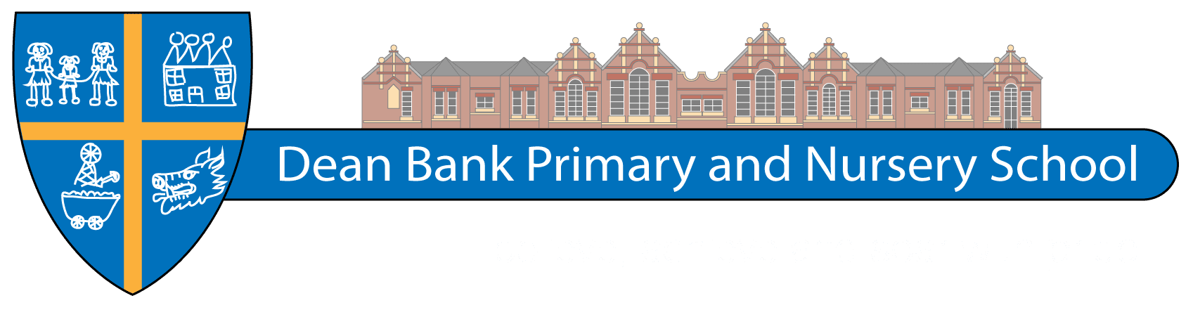

Believe, Achieve, Soar with Pride

Headteacher: Mr Craig Brown
Chair of Governors: Mr John Davison

Telephone Number: 01740 651512
Website: www.deanbank.durham.sch.uk
Email: deanbank@durhamlearning.net
Address: Dean Bank
Ferryhill
County Durham
DL17 8PP



Dear Parents,

Thank you for considering Dean Bank Primary as the school best placed to deliver the education that your child deserves. Our goal is to provide a first-class education for every child and I can assure you
that all staff work extremely hard to deliver this promise.

We believe that developing a positive relationship with parents is fundamental to a child’s education
and seek ways to engage and support parents throughout the year. We acknowledge that a good school lies at the heart of the local community and try to involve ourselves closely with projects and initiatives which bring the school and the community closer together.

We recognise that all children learn in different ways and in order to ensure they make very good progress we provide a broad and exciting curriculum in a safe and happy environment. We know that if we are to get the best from your child they need to enjoy the education that they receive. Striving to make learning fun and meaningful underpins all that we do.

The purpose of this brochure is to give you an overview of how we aim to educate and enrich the life of your child here at Dean Bank. Along with our website, www.deanbank.durham.sch.uk this should provide you with the answers to most of your questions, however, please don’t hesitate to contact me either by calling in at the school office or by using the contact details on the cover of this brochure.

Yours sincerely,
Mr Craig Brown
Headteacher

Here at Dean Bank Primary and Nursery School we aim to provide a caring, healthy, safe and
stable environment conducive to effective teaching and learning where everyone is encouraged
to believe in their ability, achieve their best and be proud of their achievements.

The school was built in 1907 to meet the needs of the ever increasing Ferryhill community due to the expansion of the local coal mining industry in the area. In those days boys and girls were kept separate, and the school was built to accommodate 1400 children.

The school roll is now approx.. 180 and consists of an EYFS Unit for 3-5 year olds, KS1 for 5-7 year olds and KS2 for 7-11 year olds.

Contents Page

Contact us / website / visitors / School App
Staff / staff absence
Governing Body
School Organisation
School Day/ Wraparound Care
Admissions
Emergency Contacts
Attendance

Curriculum
National Curriculum
School Values/ Collective Worship/Assembly
EYFS
Special Educational Needs
Assessment
Music
Religious Education
Homework

Useful information
Free Breakfast Club
Healthy Snack
Free Milk for Eligible Pupils
Reporting to Parents
Liaison
Discipline
Uniform
School Meals
Medical
Complaints
Jewellery
Educational Visits
Holidays
Photographic Consent

Contact Us

In all instances, visitors must report to the school office where they will be met by the office staff who will deal with their enquiry. Anyone who proceeds past this point must sign in using our computerised system and obtain a visitors’ pass which must be worn at all times. If you have any enquiries about the school that cannot be answered by the office staff please do not hesitate in contacting the headteacher directly using the contact details below.

Phone number 01740 651512
Email Address deanbank@durhamlearning.net

School Website

We have a comprehensive website that contains a wealth of information about how the school is organised. We encourage parents to use the website at the first instance to seek the information that they are after.

Our web site address is: www.deanbank.durham.sch.uk

The website is updated regularly. Please contact us if there is anything you would like us to include.

School App

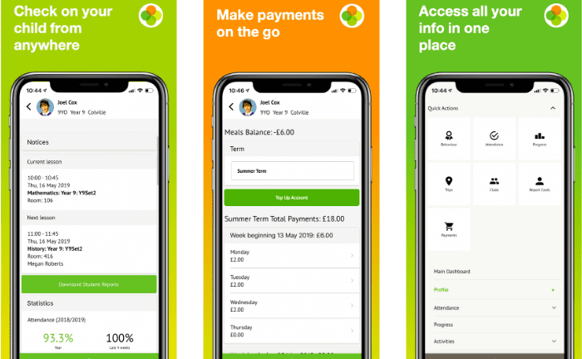
At Dean Bank we use the Arbor App for all communication with parents / carers. It is a simple, smart app which allows parents to register their child for a club or trip, book parents evening slots and manage payments all from your phone. Parents can also use the app to check in on their child's attendance, behaviour and progress.

How to get set up
- Download the free Arbor App from the Apple Store or Google Play Store
- Look for a welcome email in your inbox
- Click on the link in the email to set up your password
- Get started!


Headteacher Mr. C. Brown
Deputy Headteacher Mrs. K. Hall
Assistant Head Teacher Mr. W. Haynes

Teachers:
EYFS Miss L. Smith & Miss C Smith
Class 1 Miss. V. Evans
Class 2 Mrs. K. Hay
Class 3 Mr. W. Haynes
Class 4 Mrs. H. Kirkwood
Class 5 Mrs. K. Hall
Class 6 Miss. L. Carpenter

Teaching Assistants: Mrs J. Crute (HLTA) Maternity Leave
Mr. J. Cornish
Mr. D. Machin (HLTA)
Miss. A. Walker (HLTA)
Mrs. W. Collin
Ms. A. Griffiths
Mrs. C. Gibb
Mr. B. Hegarty
Mrs. A. Suter
Miss. S. Ebdon (Apprentice)
Miss. S Hume (Apprentice)
Miss. I. Race
Miss. T. Rogers

School Secretary’s: Mrs. S. Gilyeat
Mrs. G Youll

Caretaker: Mr. S. Hale

Cleaners: Mrs. A. Spender
Mrs. T Jones

Supervisory Assistants: Mrs. K. Gray
Ms. L McGrath
Mrs. J. Flatman
Mrs. S. Griffiths
Mrs. H. Wilson
Miss. G. Cummings

Kitchen Staff (Taylor Shaw): Mrs. L. Harrison – Unit Manager
Mrs. A. Spender
Mr. J. Bell

Crossing Patrol: Mrs. H. Wilson

In line with current safeguarding legislation, all staff and adults who work with children at Dean Bank Primary and Nursery School undergo regular Enhanced DBS checks.

Staff Absence

When a class teacher is temporarily absent for a short period of time, the school has a policy on cover following the government’s guidelines for Workforce Remodelling. In these instances, the class will be covered by a Higher-Level Teaching Assistant or pupils may be sent to other classes to work.

We try to avoid using supply teachers as this tends to unsettle many of our vulnerable pupils however sometimes this may be necessary in order to ensure the school can continue to run as normal.
School Governors

Governors are elected or appointed for a period of four years. The Governing Body meet at least twice each term.

Governing Body

Local Education Authority Representatives:

Mr. J. Quinn

Parent Representatives:

Vacancy
Vacancy

Staff Representatives:

Miss. V. Evans

Co-opted governors:

Mr. J. Davison
Ms. S. Temple
Miss G Cummings
Mrs. J. Hodgson
Mr. J. Ball
Mr. I. Shaw

Associate governors:
Mrs K Gray

The Chair of the Governing Body is Mr. J. Davison and the Clerk to the Governing Body is Mr Richard Painter, who can be contacted at School and Governor Support Service, Education Department, County Hall, Durham, DH1 5UJ.

Classroom Organisation

There are currently over 180 children who attend the school, organised into the EYFS
(Nursery and Reception), Two KS1 classes and four KS2 classes.

The School Day

The school day for 2025/26 for EYFS children is organised as follows:
EYFS use the entrance opposite St. Cuthbert’s Terrace.

Nursery (15 free hours ~ am only)

8.45am Pupils enter school for registration and morning session.
11.45am End of morning session

Nursery (15 free hours ~ pm only)

12.15pm Pupils enter school for registration and afternoon session
3.15pm End of afternoon session

Nursery (30 hours entitlement)

8:45am Pupils enter school for registration and morning session.
11:45am End of morning session

11:45am-12:30pm Lunch

2:45pm End of afternoon session

Nursery staff are here to support the overall development of children. We are very keen to work alongside parents to ensure children are toilet trained and supported with other personal hygiene.
We ask that parents supply nappies, wet wipes and spare items of clothing in a named bag to support with this. We have regular meetings with health professionals and can support parents with any
ongoing concerns. Please feel free to contact a member of staff regarding any issues.

Nursery Additional Hours
School is offering additional nursery hours at a cost of £5.00 per hour along with a cost of £2.81 for a school meal.

Reception
8:45am Pupils enter school for registration and morning session.

11:45am-12:30pm Lunch

3:05pm End of afternoon session

The school day for 2024/25 for KS1 and KS2 children is organised as follows:

Year 1/2/3
8:45am Pupils enter school for registration and morning session.

10:20am – 10:40am Morning Break

12:00am – 12:45pm Lunch break

3:10pm End of school afternoon session

Year 3/4/5

8:45am Pupils enter school for registration and morning session.

10:40am – 11:00am Morning Break

12:15pm – 1:00pm Lunch break

3:15pm End of school afternoon session

Entry to the premises for Year 1 to Year 6 pupils at the Owen Street gate.

Wraparound Care
School now offer wrapround care between the hours of 8:00am and 6:00pm.

Wraparound care will need to be booked in advance via Arbor and is payable upon booking.
The booking system will be available from 9:00am on a Monday for the following week and will close
on a Friday. We will not be able to add any children on after this time due to staffing and ratios.

Wraparound Breakfast Club | 8:00am – 8:45am | Introductory Price £2.50
Afterschool Wraparound Care | 3:15pm – 6:00pm | Introductory Price £5.00

Admissions

Admission to Reception class for children who reach compulsory school age (academic year in which
they reach their fifth birthday) takes place in September.

Application

A parent must complete “Preference Form for Admission to Primary, Infant or Junior School” on-line at Durham County Council, School Places and Admissions, before Thursday 15th January 2026.

Confirmation of a place is made by the end of April 2026. The Education Committee is legally
responsible for all admissions to County and Controlled Schools. It may not be possible to offer your
child a place at your chosen school, if that school receives more applications than it can take within its admission limit. Where this happens, the Authority will consult the Governing Body of the School and allocate places according to the following criteria in order of priority:

Medical Reasons
Pupils with very exceptional medical factors directly related to school placement. Applications under
this criterion should be supported by written evidence from a doctor.

Family Links
Pupils who have a brother or sister already attending the preferred school or associated primary school or on the same site and who is expected to be on role at the school at the time of admission.

Distance
Pupils who live nearest the preferred school, measured by the shortest walking route. This will be
based on the parents' addresses. The authority will, however, consider the overall availability of school places in an area to ensure that no children have an unreasonable distance to walk. This may override proximity to the nearest school.

Please Note: In the event of over-subscription within criteria 1 or 2, places will be granted to those pupils living nearest to the preferred school (measured by the shortest walking distance).

Mid-Year Transfer:

The Local Education Authority provides a common In Year Application form to parents requesting information relating to the parent’s and child’s reason for transfer and their preference of school(s).

The LEA will confirm the offer of a place for a school to parents who live in County Durham as well as notifying the school and relevant LEA.

If the application is for a Voluntary Aided school, the LEA will refer the application to the Governing
Body of the school, which will decide and notify the LEA who will confirm the offer of a place to parents. Parents who are refused admission must be offered the right of appeal.

Admission Limit: 30

Emergency Contacts

It is vitally important that we have an updated record of several emergency contact phone numbers
held securely at our main office in case we need to contact home at any point during the school day.

If you change your phone number you must inform the school immediately so that we can update our records. These can also be done via Arbor.

All parents/carers are expected to complete a ‘safe adult list’ form to ensure the safety of the children
at the end of the day, along with an emergency adult to collect children.

Medical

Please notify the school of any allergies or special medical problems which affect your child.

If your doctor advises that your child should be given medication during the school day then please obtain and complete the appropriate form from the school office. Medication should be clearly
labelled with the child’s name and in it’s original packaging.

Please note staff can only legally administer medication if it is needed more than 3 times per day.

UNDER NO CIRCUMSTANCES SHOULD CHILDREN ARRIVE AT SCHOOL WITH THEIR OWN MEDICATION

Safeguarding

If you have any concerns regarding the safeguarding of either your own or other children in school please contact a member of our safeguarding team:

Mr Craig Brown
Mrs Kirsty Hall
Mr Will Haynes
Mrs Katie Hay

Complaints Procedure

If a parent has a concern regarding their child’s education, in the first instance they should speak to
their class teacher who will record this on a ‘CPOMS’ and follow this up so the matter can be resolved.

If there is a continuing concern the Head Teacher will become involved to ensure matters are resolved
to the expectation of all concerned.

If the matter is more serious the Head Teacher should be contacted in the first instance. In the event that this does not resolve the matter, then please contact the school office or the Local Authority to obtain a copy of the formal Complaints Procedure which includes a written complaint format which
is then presented to school. Further information can be found at www.gov.uk/complain-about-school.

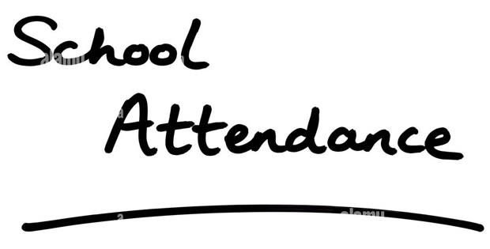
Attendance

The school actively encourages full attendance at all times throughout the school year. If your child is absent through ill health, you must inform the main school office before 9.15 a.m. on the first day
of absence, otherwise it will be recorded as unauthorised. We have a duty to monitor children’s attendance very closely throughout the school year and any causes of concern will be monitored by the Attendance Officer and reported to the Attendance Enforcement Team.

Term Time Holidays and Absences

Please note that parents have a legal obligation to ensure their child attends school regularly during
term time. The school’s attendance is closely monitored by the school itself as well as the Local
Authority and Ofsted.

From September 2013 headteachers will only be able to authorise absence in term time due to ‘exceptional circumstances’. All reference to allowing family holidays have been removed. We therefore actively discourage children taking term time holidays as missed lessons adversely affect the child’s progress in school.

Dean Bank Primary School considers every request for holiday leave on an individual basis, but is
unlikely to be granted.

The appropriate leave of absence form must be collected and completed from the school office. Applications should be made at least 2 weeks before the planned absence.

Medical Appointments During School Hours

If your child has a half or full day medical appointment a leave of absence form must be completed and proof of the appointment must be presented. If your child is just ‘nipping’ to a quick medical appointment please present the appointment card at the office as they are being collected.

Unavoidable Closure

There may be occasions when, due to circumstances beyond our control, it will be necessary to close
the school. In times of severe weather, heating breakdown, power failures, etc. we may have very little notice of such closure. Every effort will be made to inform parents before the start of school, including notifying the local radio stations, Durham County Council Website and the schools Facebook page or website.

No child will be sent home unless arrangements for them have been made.
Curriculum

Early Years Curriculum

Pupils in our Nursery and Reception are taught the Early Years Foundation Curriculum which includes
Prime and Specific areas of learning:

Communication and Language
Physical Development
Personal, Social and Emotional Development

Literacy
Mathematics
Understanding the World
Expressive arts and Design

If you have any questions regarding our Early Years provision, please contact the main office to make
an appointment with Mr Brown or Miss Smith.

KS1 and KS2 ~ National Curriculum

After EYFS, all children are taught English, Mathematics, Science, Computing, History, Geography, Art, Design and Technology, Music and PE in accordance with the requirements of the National Curriculum. RE is taught in accordance with the Durham Agreed Syllabus. PSHCE reflects national and local
guidance. KS2 children are also taught French as a modern foreign language.

Special Educational Needs (SEND)

All children at Dean Bank Primary School receive an education that is appropriate to their needs and progress is carefully monitored by the class teacher. Children who have special needs are recognised at an early stage so that appropriate intervention can be directed towards them promptly. This may entail working with a classroom assistant or working with children from other classes as part of small group support.

Gifted and Talented (G&T)

Your child may be recognised as being more able and talented therefore need opportunities to further enhance their talents. In such instances, the class teacher will work hard to provide learning opportunities to further their progress.
Assessment

Teachers use a variety of methods to regularly assess children’s ability.

This information is fed into our pupil tracking systems and enables us to monitor the progress that all children make.

If we have any concerns about your child’s progress then we will contact you at the earliest opportunity to discuss the action that we are taking to try and rectify the situation.

Children are more formally assessed at the end of each Key Stage.

At eleven years old all children take the SAT tests, and this information is used as a measure by the government to comment on how well a school is doing. If your child is in Y6, it is very important that
they attend school during the week of the SAT’s, which is usually in the second week of May.

Music

Music is taught in all classes each term by the class teacher. Furthermore, there may be an opportunity for your child to receive extra, more specialist music tuition delivered from Durham Music Service from Year 3 upwards. Please contact the school for further details.

Religious Education

Religious Education is taught throughout the school in line with statutory government regulations and the Durham County Agreed Syllabus. The Christian content of R.E. is delivered alongside multi faith teaching to promote tolerance and understanding of other faiths.

Homework

Homework is set regularly and chosen by teachers depending on the needs of their class. Spending time learning with your child each week can really enhance their education.

It is expected that all children are heard read each day at home and their personal organisers support this and are monitored by class teachers. All children have a reading record book and this must be signed 3 times per week by a parent/carer to support the school/home partnership.

English, Maths and Topic specific homework will be given as appropriate.
Extra-Curricular Activities

A wide range of extra-curricular activities are offered at various times throughout the school year.
These may include art and craft, football, and extra study support. Details will be given on class dojo.

Breakfast Club

Due to the continued generosity of Greggs and Livin we hold a FREE Breakfast Club each morning from 8.30am to 8.45am where staff serve a choice of healthy breakfasts. If behaviour is poor then children
may be banned from Breakfast Club for one week, on return if behaviour continues to be poor they may be banned for the rest of the half term. Breakfast Club is bookable via Arbor.

Healthy Snack

Under the Government’s School Fruit and Vegetable Scheme, each child aged four to six in LEA maintained schools will be entitled to receive a free piece of fruit or vegetable each school day.

Reporting to Parents

The school endeavours to keep parents informed as much as possible about the school and their child’s progress. Communication with parents is effected in a wide variety of ways:

Pupil Personal Organisers
Class DOJO
Parent Consultations
Class open events
Newsletters
School website
Letters to parents
Individual meetings
Facebook

PLEASE NOTE

To ensure the daily timetable is not disrupted we ask parents who wish to speak to class teachers specifically, or at length, to make a mutually convenient appointment at the school office, Parents wishing to speak to the headteacher on any matter are welcome and encouraged to make an appointment at the school office. For quick messages or updates, staff are outside for 5 minutes
before the start of the day.

Discipline
High standards of discipline are expected throughout the school and pupils are expected to
demonstrate self-discipline based on respect and caring for each other and their property. Courtesy
and good manners are expected at all times. Wherever possible positive methods of behaviour management are practiced to promote good behaviour, however it is sometimes necessary to withdraw privileges and enforce sanctions in order to deal with unacceptable conduct. At times parents may be called into school to discuss particular incidents of concern. (See Behaviour Policy)

School Meals

Meals are prepared and cooked on the premises. Where a child has a medical problem requiring a particular diet, arrangements can be made- please contact the school office for details.

From 1st September 2014 any child that attends a Reception or KS1 class will be provided with a Universal Free School Meal as per the government initiative.

For all other children the cost of a school lunch remains the same as last year:

£2.81 per day (£14.05 per week)

To ensure sufficient school lunches are provided and to avoid confusion meal payments should be paid
on the first day of each week, which is usually Monday. Although children are able to swap between school lunches and packed lunches we expect that they have the same for a whole week.

Please ensure all payments are made via Arbor.

Packed lunches can also be prepared for those children entitled to a free meal for educational visits.

Packed lunches are allowed, but all uneaten food must be taken home and a healthy packed lunch should be provided. (See Packed Lunch Policy)

Free School Meals

If you are receiving Universal Credit. Income Support, Income Based Job Seekers Allowance, Income-related Employment and Support Allowance, Guaranteed element of State Pension Credit or where a parent is entitled to Working Tax Credit run-on, or you are in receipt of Child Tax Credit.

Please contact the school office for further details.

Educational Visits and Visitors

Educational visits are organised for pupils to enrich the curriculum and provide children with learning opportunities not available in the classroom. If children’s behaviour may put themselves or others at
risk then parents may be asked to accompany their child on the visit. If a responsible adult cannot accompany the child then they may be unable to attend the visit.

Charging Policy

Parents are asked to support these visits by making voluntary contributions to cover the cost of their child's visit. These costs are kept to a minimum and are based on the assumption that the parents of each child taking part in the activity will make a contribution. A parent's unwillingness to make a contribution will not prevent their child from taking part in the activity, but if enough contributions are not received, it may be necessary to cancel the visit.

Personal Property

Mobile telephones and other items of value must not be brought into school unless written permission has been given and then handed in to the school office for the whole day. School WILL NOT accept responsibility for the loss of, or damage to, items of this type. All items of clothing and articles brought into school should be clearly labelled with the child's name.

Jewellery

Jewellery other than a wrist watch SHOULD NOT BE WORN. If a child has to wear earrings, they must be of the small stud type. For P.E., games and swimming, earrings must be removed (by the child).

School Uniform

ALL PUPILS from Reception through to Year 6 are expected to wear school uniform daily.

Sweatshirts and jumpers are navy blue and the polo shirts are red. Trousers may be worn by all children. School shoes should be black, including trainers. If children come to school wearing coloured trainers or unsuitable shoes, they will be provided with black plimsolls for the day if shoes cannot be brought in.

A price list of items with the school badge and order forms are available through the school website. Although some items are kept in school.

For P.E. it is essential for each child to have the appropriate clothing and footwear, Red t-shirts and
black shorts. These are available from the school office.

Children also need to be provided with gym shoes/plimsolls for indoor and tracksuit and trainers for outdoors.

Children going swimming will require costume/trunks (not shorts), swimming hat and a towel.

Children are expected to have appropriate haircuts/colours as in our uniform policy available on the school website.

