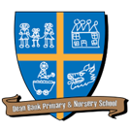
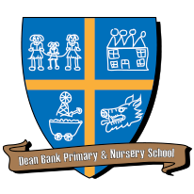
Dean Bank Primary School
Long Term Plan for Foundation Subjects: Year 1

 | Autumn |  | Spring |  |  | Summer
Science | Animals including humans |  | Everyday Materials |  | Seasons | Plants
History | What is History? |  | History at Home |  |  | Explorers
Geography | My Place |  | What can I find in Ferryhill? |  |  | What is the United Kingdom like?
Art and Design | Drawing - Lines |  | Painting – Primary Colours and Brushstrokes |  |  | Printing – Environmental Patterns
Design and Technology | Mechanisms – Moving Card |  | Structures – Bird Table |  |  | Cooking and Nutrition – Fruit Skewers
Music | Keeping Pulse | Sound Patterns | Pitch |  |  | Musical Symbols
Languages | Greetings |  | Numbers |  |  | Colours
PE | Athletics – Honey Pot | Gymnastics – Making Shapes | Dance – Themes and Dreams | Athletics/ Games – Colour Match or Beanbag Throw |  | Games - Rolla Ball | Athletics – Off, Up and Away
RE | What do Christians believe about God? | Why are gifts given at Christmas? | Why is Jesus special to Christians? | What is the Easter story? |  | What can we find out about Buddha?
RE | What can we learn about Christianity from visiting a Church?
Computing | Unit 1.1. – Online Safety and Exploring Purple Mash |  | Unit 1.6 – Animated Stories |  |  | Unit 1.7 – Coding | Unit 1.9 – Technology Outside of School

