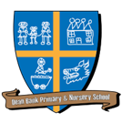
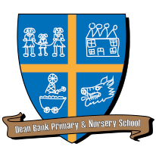
Dean Bank Primary School
Long Term Plan for Foundation Subjects: Year 2
 | 1a | 1b | 2a | 2b | 3a | 3b
Science | Use of everyday materials | Animals including humans | Living things and their habitats |  | Plants
History | Why are some places special? |  | Fantastic Firsts |  | All change: Holidays now and then
Geography | Why is my world wonderful? |  | Wherever next? |  | Holidays – where shall we go?
Art and Design | Draw/Paint: Landscapes |  | Make/Print: Animal Patchwork Prints and 3D animals |  | Paint: Children’s Choice
Design and Technology | Mechanisms – Wheels and axles |  | Textiles – Templates and joining techniques |  | Cooking and Nutrition – preparing fruit and vegetables
Music | How does music help us to make friends? | What stories does music tell us about the past? | How does music make the world a better place? | How does music teach us about our neighbourhood? | How does music make us happy? | How does music teach us about looking after our planet?
Languages | Greetings | Colours and Numbers | In My Town |  | Minibeasts
PE | Games – 10 Point Hoops | Gymnastics – Families of Actions | Dance – Cat Dance | Games – Piggy in the Middle | Games – Kick Rounders | Athletics – Furthest Five/Pass the Baton/Take Aim
RE | Why is the Bible special to Christians? | How and why is light important at Christmas? | What does it mean to belong in Christianity | How do Christians celebrate Easter? | How do Buddhists show their beliefs?
 | What can we learn from the story of St Cuthbert? |  |  |  | What can we learn about our local faith communities?
Computing | Unit 2.1 - Coding | Unit 2.2 – Online Safety | Unit 2.3 – Spread - sheets |  | Unit 2.7 – Making Music | Unit 2.8 – Presenting Ideas

