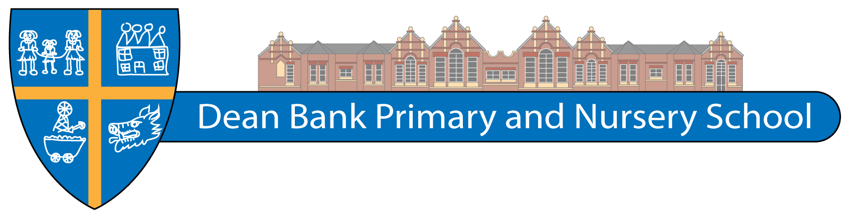
Dean Bank Primary School
Long Term Plan 2022-2023 – Year 6
 | 1a | 1b | 2a |  | 2b | 3a | 3b
Class text | Kensuke’s Kingdom | Cloud Tea Monkeys | Goodnight Mister Tom / The Arrival |  |  | The Nowhere Emporium
Science | Electricity | Animals including humans (diet, exercise and circulation) | Living things and their habitats | KS2 topics revision |  | Light | Evolution and inheritance
History | What’s in a name?  (Local history – WW1) |  | How did WW2 impact the lives of children in Durham and the rest of the UK? |  |  | Crime and Punishment
Geography | Fantastic forests – Why are they so important? |  | How has our local area changed over time? |  |  | Destination Sau Paulo! What do places have in common?
Art and Design | Draw: Local Landmarks  Architectural Art – Norman Foster, Stephen Wiltshire |  | Make: 3D Soap Sculptures  Barbara Hepworth |  |  | Print/Paint: Stencilling  Street Art – Banksy, Lewis Hobson (Durham Spray Paints)
Design and Technology | Electrical systems – more complex switches and circuits  Vehicle powered by a circuit |  | Structures – frame structures  Anderson Shelter |  |  | Food – celebrating culture.  Making fajitas
Music | Developing Melodic Phrases  How does music bring us together? | Understanding structure and form  How does music connect us with our past? | Gaining confidence through performance  How does music improve our world? | Exploring notation further  How does music teach us about our community? |  | Using chords and structure  How does music shape our way of life? |  | Respecting each other through composition  How does music connect us with the environment?
Languages | Phonics Lessons (1-4) & Core Vocabulary | The Date | Do You Have A Pet? |  |  | School
PE | Games (Invasion) – Wide Attack (netball) | Gymnastics – Acrobatic Gymnastics | Dance – own theme | Games (Invasion) – Fives and threes/ Tag Rugby |  | Games (net/wall) Long and thin or short and fat? | Games (St + F) – Pairs cricket  Athletics – Distance Challenge Unit 3 All areas  Swimming (non-swimmers)
RE | What can we learn about religious diversity in our area?  What can we find out about a local Muslim community? | What do the gospels tell us about the birth of Jesus? | How and why do people care about the environment? | Why are Good Friday and Easter Day the most important days for Christians? |  | So what do we now know about Christianity?
Computing | Unit 6.1 Coding | Unit 6.2 – Online Safety  Unit 6.4 – Blogging | Unit 6.6 – Networks |  |  | Unit 6.7 – Quizzing |  |  | Unit 6.9 – Spreadsheets

