

**Thank you….**

We would like to say a big thank you to all parents and carers that have supported us through opportunities such as Stay and Play sessions and reading workshops.

We really do believe that having a strong home-school link helps your children to make the best possible progress.

We will be running another Stay and Play session on **Friday 8th February 2019, 8.45am-10.30am.**

Keep a look out for further sessions and some special workshops after half term. We look forward to your continued support this term.

Early Years Newsletter

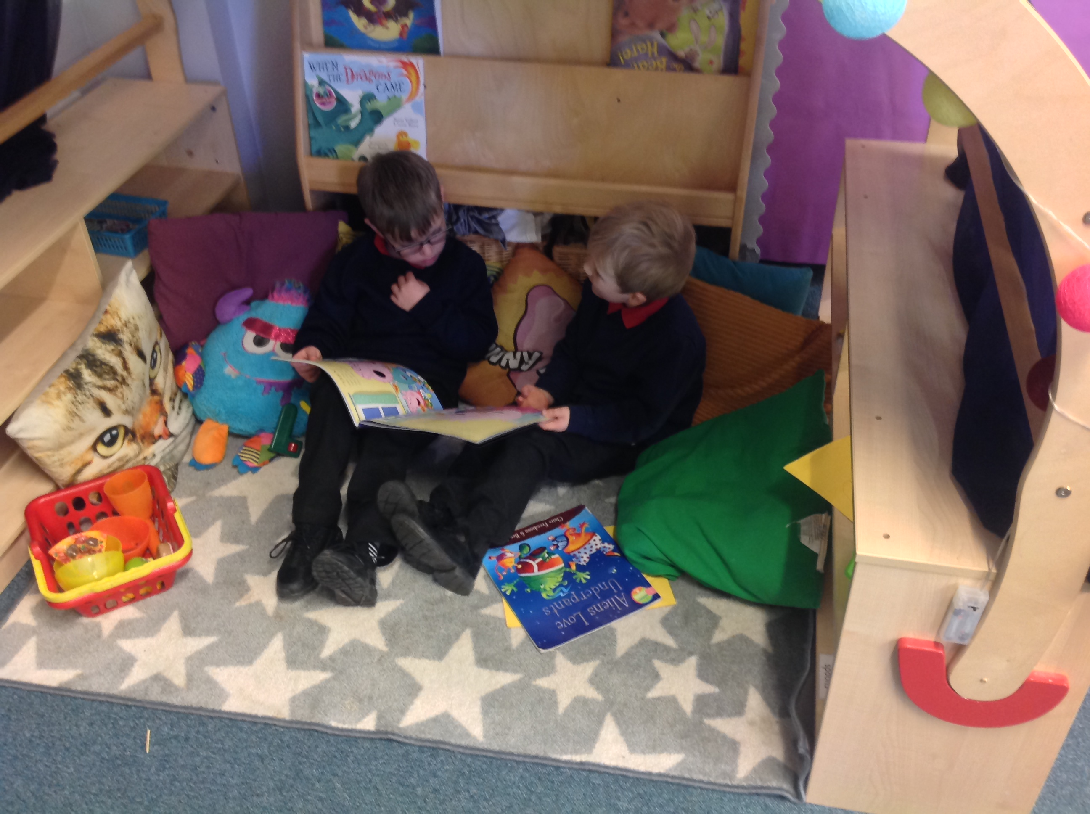

**Important dates**

* Stay and Play - Friday 8th February 2019, 8.45am-10.30am.
* Parents evening - 12th February 2019

**Parent helpers**

At Dean Bank we welcome parent helpers and there are many opportunities that will benefit tremendously from the input of parents, from educational visits to listening to readers.

If you would like to volunteer, could you please contact Mr Wood or Miss Anderson by email:

[w.wood300@durhamlearning.net](mailto:w.wood300@durhamlearning.net)

[j.anderson300@durhamlearning.net](mailto:j.anderson300@durhamlearning.net)

**A note from the teachers**

Thank you for helping all of the children in EYFS make a successful start last term. We have been busy developing skills within the 7 areas of learning through fun topics such as Ourselves, Celebrations and, of course, Christmas! We had many changes last term but the children have adjusted to new routines and are settling in well.

**What we are learning this term**

Our topics this term are Space, The Deep Blue Sea and Emergency!

This term we will be

**Nursery-**

* Practising our listening skills
* Practising turn taking and kind hands
* Talking about stories
* Developing our mark making

**Reception-**

* Practising our phonics
* Learning to read words on sight
* Learning to write sentences
* Learning what subtraction is
* Learning to half an object and quantity

**Home learning**

Just a reminder that developing a love of reading begins at home. In addition to reading books for Reception, we will be starting to send home stories for Nursery Children to share with you. If you would like some ideas or suggestions to encourage your child to read, please feel free to ask any member of the Early Years team, as we will be happy to help you out!

**Believe, Achieve, Soar with Pride**